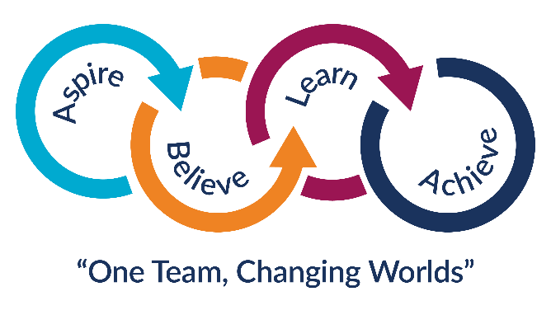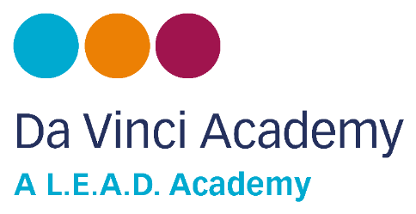

|  |  |  |  |  |  |
| --- | --- | --- | --- | --- | --- |
| **STUDENT DETAILS** | | | | | |
| **Legal Forename** |  | | | **Legal Surname** |  |
| **Preferred Forename** |  | | | **Preferred Surname** |  |
| **Previous Surname** |  | | | **Gender** |  |
| **Date of Birth** |  | **Year** |  | **Home Phone** |  |
| **Address** |  | | | | |

**WE ARE REQUIRED TO HOLD DETAILS OF AT LEAST 3 CONTACTS FOR EACH STUDENT**

|  |  |  |  |  |  |  |  |  |
| --- | --- | --- | --- | --- | --- | --- | --- | --- |
| **CONTACT 1** | | | | | | | | |
| **Title** |  | **Forename** |  | | **Surname** | |  | |
| **Address** |  | | | | | | | |
| **Mobile Tel.** |  | | **Home Tel.** |  | | **Work Tel.** | |  |
| **Email** |  | | | | | | | |
| **Relationship To Student** |  | | | | | | | |
| **CONTACT 2** | | | | | | | | |
| **Title** |  | **Forename** |  | | **Surname** | |  | |
| **Address** |  | | | | | | | |
| **Mobile Tel.** |  | | **Home Tel.** |  | | **Work Tel.** | |  |
| **Email** |  | | | | | | | |
| **Relationship To Student** |  | | | | | | | |
| **CONTACT 3** | | | | | | | | |
| **Title** |  | **Forename** |  | | **Surname** | |  | |
| **Address** |  | | | | | | | |
| **Mobile Tel.** |  | | **Home Tel.** |  | | **Work Tel.** | |  |
| **Email** |  | | | | | | | |
| **Relationship To Student** |  | | | | | | | |

|  |  |
| --- | --- |
| **PARENTAL RESPONSIBILITY** | |
| Please confirm the **name(s)** of people with parental responsibility. Anyone who has Parental Responsibility has a right to request information from the school. | |
| **1** |  |
| **2** |  |

**MEDICAL INFORMATION**

|  |  |  |  |
| --- | --- | --- | --- |
| **MEDICAL PRACTICE** | | | |
| **Practice Name:** |  | **Practice Tel:** |  |
| **Doctor Name:** |  | | |
| **Practice Address:** |  | | |

|  |
| --- |
| **MEDICAL CONDITIONS** |
| **Please provide details of any medical conditions the school should be aware of:** |
|  |

|  |
| --- |
| **DIETARY NEEDS** |
| Please outline any special dietary requirements of your child: |
|  |

|  |  |
| --- | --- |
| **MEDICATION** | |
| Is your child allergic to any medication? | YES 🞏 NO 🞏 |
| If yes please give details |  |
| Does your child require medical treatment/medication in school? | YES 🞏 NO 🞏 |
| If yes please give details: |  |
| **Please note – Parental Consent Form 8 MUST be completed if your child requires medicines in school. Please obtain this form from the School Reception** | |

|  |
| --- |
| **Tetanus** |
| When did your child last have a tetanus injection? |

**Please note: If your child’s medical needs change it is your responsibility to update the school**

|  |
| --- |
| **CONSENT** |
| Please log onto the School Gateway App to complete consent for;   * Media and publication * Sporting fixtures * Day visits/trips * Emergency consent * Biometrics (fingerprints for lunches) |

|  |
| --- |
| **STUDENT ETHNICITY** |
| Please select one ethnic background from the following: |
| 🞏 White – British 🞏 Asian or British Asian – Indian  🞏 White – Irish 🞏 Asian or British Asian – Pakistani  🞏 White – Traveller of Irish heritage 🞏 Asian or British Asian – Bangladeshi  🞏 White – Gypsy/Roma 🞏 Asian or British Asian – Any other Asian background  🞏 White – Any other white background  🞏 Mixed – White & Black Caribbean 🞏 Black or Black British – Caribbean  🞏 Mixed – White & Black African 🞏 Black or Black British – African  🞏 Mixed – White & Asian 🞏 Black or Black British – Any other black background  🞏 Mixed – Any other mixed background  🞏 Chinese  🞏 Any other ethnic background |

|  |  |  |  |
| --- | --- | --- | --- |
| **STUDENT LANGUAGE** | | | |
| First language |  | Any other Language |  |

|  |
| --- |
| **STUDENT RELIGION** |
| Please select one ethnic background from the following: |
| 🞏 No Religion 🞏 Jehovah’s Witnesses  🞏 Buddhism 🞏 Judaism  🞏 Christianity 🞏 Sikhism  🞏 Hinduism 🞏 Other – Please state ______________________________  🞏 Islam |

|  |  |  |  |  |  |
| --- | --- | --- | --- | --- | --- |
| **OTHER INFORMATION** | | | | | |
| **Refugee** | YES 🞏 NO 🞏 | A**sylum Seeker** | YES 🞏 NO 🞏 | **Traveller** | YES 🞏 NO 🞏 |

|  |
| --- |
| **SERVICE PUPIL PREMIUM (SPP)** |
| Is your child eligible for Service Pupil Premium? Yes 🞏 No 🞏 |
| A child is eligible if he/she meets any one of the following criteria:   * One of their parents is serving in the regular armed forces * They have been registered as a ‘service child’ in the school census at any point since 2011 * One of their parents died whilst serving in the armed forces and the pupil receives a pension under the Armed Forces Compensation Scheme or the War Pensions Scheme * Pupils with a parent who is on full commitment as part of the full time reserve service are classed as service children |

|  |
| --- |
| **LAC STATUS (Looked after Child – in foster care/adopted)** |
| Currently LAC 🞏 Previously LAC 🞏 Prefer not to say 🞏 Not Applicable 🞏 |
| If currently LAC please provide details of the relevant local authority: |
| Under the Children Act 1989, a child is looked after by a local authority if s/he is in their care or is provided with accommodation for more than 24 hours by the authority. They include the following: (i) children who are accommodated by the local authority under a voluntary agreement with their parents (section 20); (ii) children who are the subject of a care order (section 31(1)) or interim care order (section 38); and (iii) children who are the subject of emergency orders for the protection of the child (section 44)’ |

|  |  |  |  |
| --- | --- | --- | --- |
| **SPECIAL NEEDS INFORMATION** | | | |
| EHCP 🞏 | SEN SUPPORT 🞏 | | no SEN 🞏 |
| Diagnosis. eg. adhd/asd | |  | |
| Present support. eg. Learning/emotional/behaviour | |  | |
| Any outside agency involvement | |  | |

|  |
| --- |
| **ADDITIONAL INFORMATION** |
| We are keen to provide your child with the best possible support, please provide us with any other information that you feel will aid us in our attempts to do this. |
|  |

**As a Parent/Guardian, it is your responsibility to inform the Academy of any changes to the information you have provided or the level of consent given.**

If you need any help or support in completing this form, please contact your child’s Pastoral Leader.

|  |  |
| --- | --- |
| I confirm that the information contained in this form is complete and correct | |
| Parent/Guardian Signature: | Date: |

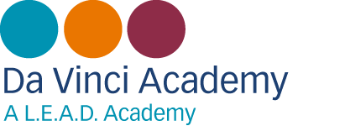

Dear Parent/Carer,

As a school we are able to secure additional funding for any student who is eligible for free school meals even if the student chooses not to take the meal each day.

To enable us to secure as much of this additional funding as possible, we would be very grateful if you could provide us with the following information for the parent/carer who claims benefits so that we can check eligibility.

It is important that you provide this information even if your child currently receives free school meals as it will enable us to ensure that they are able to continue to receive them when they start at Da Vinci in September.

|  |  |  |  |
| --- | --- | --- | --- |
| **Free School Meals Eligibility Check** | | | |
| My child currently receives free school meals at primary school YES 🞏 NO 🞏 | | | |
| **Name of person claiming benefits** | |  | |
| **National Insurance Number:** |  | **Date of Birth:** |  |
| **Please sign to authorise us to carry out the check:** | |  | |

Once we have received your details, the school will use the new Free School Meals Checking Service to check if you are eligible.

Please note - You can also apply for FSM online yourself by using the link below:

<https://www.cloudforedu.org.uk/ofsm/link2ict>

If your application for Free School Meals is successful, your child will then be able to have a free meal at lunch time up to the value of £2.20. The school will also receive extra funding from the Government to use in support of teaching and learning, so checking to see if you are eligible is important.

If your application for Free School Meals is not successful, your child won’t be eligible for a free meal. The checking service system does however store your details and re checks them every week so if you ever have a change in circumstances whereby you will be eligible for Free School Meals, the system will pick this up and will notify us.

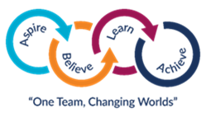

**Mobile Phones**

Students should not use mobile phones in the School building. This is to preserve the privacy and safety of all students and staff and to ensure the focus in School remains on learning.

Students who use their phones in School can expect to have them confiscated and returned at the end of the day. Those who persistently use their phones will have them confiscated until a parent or carer can come to school to collect.



**Privacy Notice – Secondary Schools – Summary Version**

Da Vinci Academy processes personal data about its pupils and is a ‘data controller’ in respect of this for the purposes of the Data Protection Act 1998.

It processes this data to:

* Support its pupils’ teaching and learning
* Monitor and report on their progress
* Provide appropriate pastoral care
* Support a young person in their transition to a post 16 provider of education or training
* Assess how well the school as a whole is doing.

This data includes contact details, national curriculum assessment results, attendance information, characteristics such as ethnic group, special educational needs and any relevant medical information.

This data may only be used or passed on for specific purposes allowed by law. From time to time the school is required to pass on some of this data to local authorities (LA’s), the Department for Education (DfE), and to the agencies that are prescribed in law, such as the Qualifications and Curriculum Authority (QCA), Ofsted, the Young People’s Learning Agency (YPLA), the Department of Health (DH) Primary Care Trusts (PCT), and the Skills Funding Agency (SFA) that require access to data for the Learner Records Service. All these are data controllers in respect of the data they receive and are subject to the same legal constraints by law in how they deal with the data.

Pupils as data subjects, have certain rights under the Data Protection Act, including a general right to be given access to personal data held about them by the data controller. The presumption is that by the age of 12 a child has sufficient maturity to understand their rights and to make an access request themselves, if they wish. A parent would normally be expected to make a request on a child’s behalf if the child is younger.

If you wish to access your personal data, or that of your child, then please contact the relevant organisation in writing. Details of these organisations can be found in the full text version of the privacy notice (on our website), or for those pupils/parents where this is not practical, a hard copy can be obtained from your school by contacting us by telephone on 01332 831515, email at [office@davinci.derby.sch.uk](mailto:office@davinci.derby.sch.uk) or in writing to Da Vinci Academy, St Andrews View, Breadsall, Derby, DE21 4ET.

**Post 16 Providers attended by Derby Learners**

The school will share demographics and personal characteristics of a young person with post 16 providers who are a progression route for Derby learners. These providers may be able to offer choices to the young person which could improve their life chances and enable them to make a positive contribution. The

**Privacy Notice – Secondary Schools – Summary Version (Cont.)**

information will also be shared as part of the September Guarantee Process which is a statutory obligation for Children Services to ensure that all young people are offered appropriate learning opportunities.

The information that will be shared is outlined in Annex 1 of the full text version of the privacy notice.

However, parents, or the pupils themselves if aged 16 or over, can ask that no information beyond name and address (for pupils parents) be passed on to Post 16 providers. If as a parent, or as a pupil aged 16 or over, you wish to opt-out and do not want post 16 providers to receive from the school, information beyond name and address, then please contact your school in writing to Da Vinci Academy, St Andrews View, Breadsall, Derby, DE21 4ET or by telephone on 01332 831515.

Your attention is drawn to the full text version of this Privacy Notice, which gives supplementary information about the processing of pupil data by the organisations mentioned above, and gives greater details of how pupil data is processed and the rights or parents and pupils.



Dear Parent/Carer

There may be times whilst your child is attending Da Vinci Academy when it will be beneficial for them to be assessed. This usually comprises reading and spelling tests and/or assessments designed to help us to understand the way your child works best. This helps us to offer your child the most suitable support, either in class, in small literacy and numeracy withdrawal groups or literacy and numeracy booster classes.

There may also be occasions when it is necessary to screen your child to determine whether support in Public Examinations is needed. We would like your permission to carry out these assessments when necessary and would ask you to return the attached consent slip to us as soon as possible.

If you have any queries regarding either of these matters, please contact the Learning Centre and we will be happy to discuss them with you.

Yours sincerely

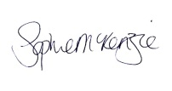

Sophie McKenzie

Assistant Headteacher: Intervention and Inclusion (SENDCo)

All information provided will be treated in confidence, in accordance with the Data Protection Act 1998 and used for the purpose of assessing your child’s special educational needs. The information may be shared with the other professionals involved in assessing and providing for your child’s special educational needs.

----------------------------------------------------------------------------------------------------------------------------------------------

Da Vinci Academy

Student Name: ________________________________

**I/We** give permission for our **son/daughter** to be assessed by the Additional Educational Support Team.

We understand that we can contact the Learning Centre for further information if we have any concerns.

Signature: _____________________________ Relationship to Child: ____________________

Printed Name: ____________________________________________